Name…………………..………. Tutor Group……………

Personal Statement

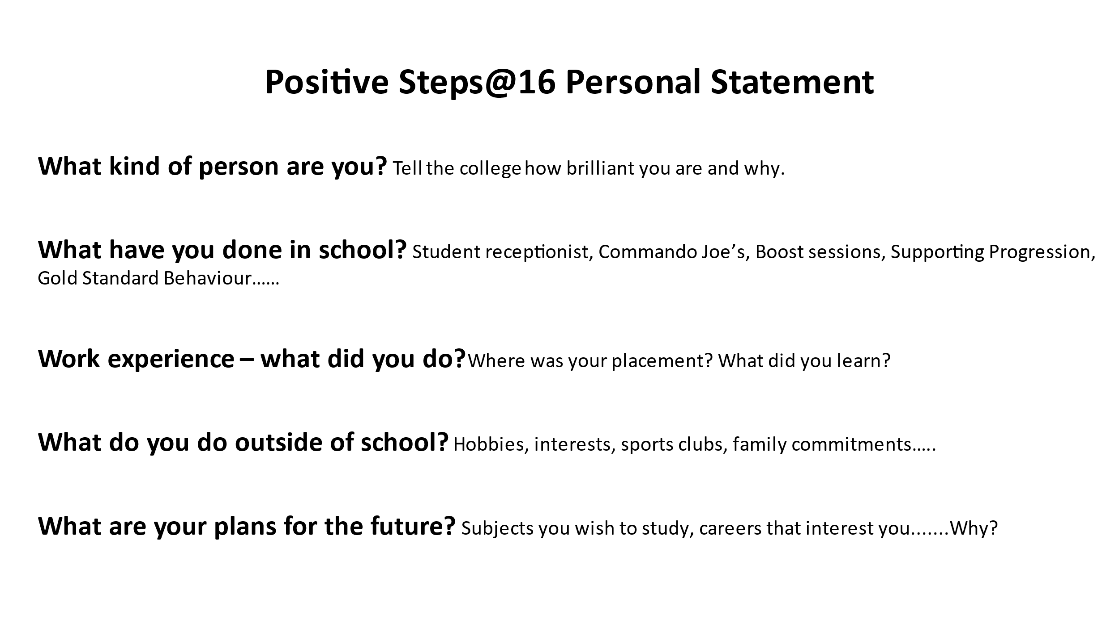

The “5 MINUTE PERSONALITY TEST”
In each line, put the number “4” next to the word that best describes you in that line; a “3” next to the word that describes you next best; a “2” to the next best word, and a “1” by the word that least describes you. On each horizontal line of words, you will then have one “4”, one “3”, one “2”, and one “1”.
For example: One choice for the first line of words would be as follows:
3 Likes Authority 4 Enthusiastic 2 Sensitive Feelings 1 Likes Instructions
L | O | G | B
1. ____ Likes Authority | ____ Enthusiastic | ____ Sensitive Feelings | ____ Likes Instructions
2. ____ Takes Charge | ____ Takes Risks | ____ Loyal | ____ Accurate
3. ____ Determined | ____ Visionary | ____ Calm, Even Keel | ____ Consistent
4. ____ Enterprising | ____ Very Verbal | ____ Enjoys Routine | ____ Predictable
5. ____ Competitive | ____ Promoter | ____ Dislikes Change | ____ Practical
6. ____ Problem Solver | ____ Enjoys Popularity | ____ Gives In To Others | ____ Factual
7. ____ Productive | ____ Fun-Loving | ____ Avoids Conflict | ____ Conscientious
8. ____ Bold | ____ Likes Variety | ____ Sympathetic | ____ Perfectionist
9. ____ Decision Maker | ____ Spontaneous | ____ Nurturing | ____ Detail-Oriented
10. ____ Persistent | ____ Inspirational | ____ Peacemaker | ____ Logical
____ TOTAL “L” | ____ TOTAL “O” | ____ TOTAL “G” | ____ TOTAL “B”

Total up the numbers for each vertical column (L, O, G, B).

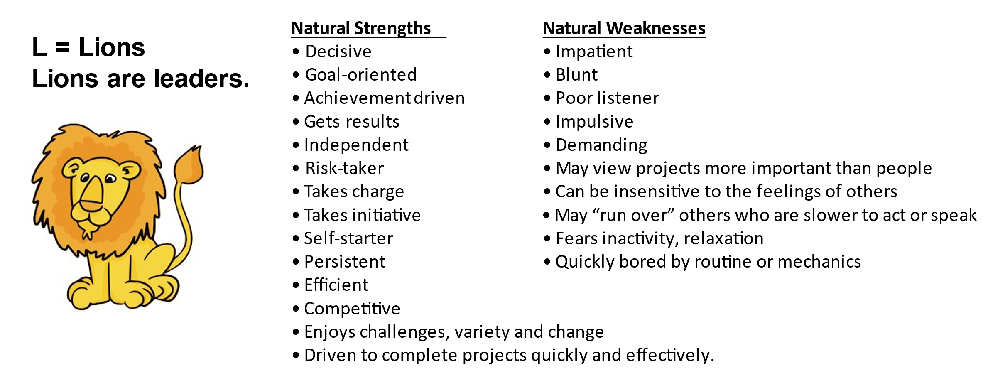
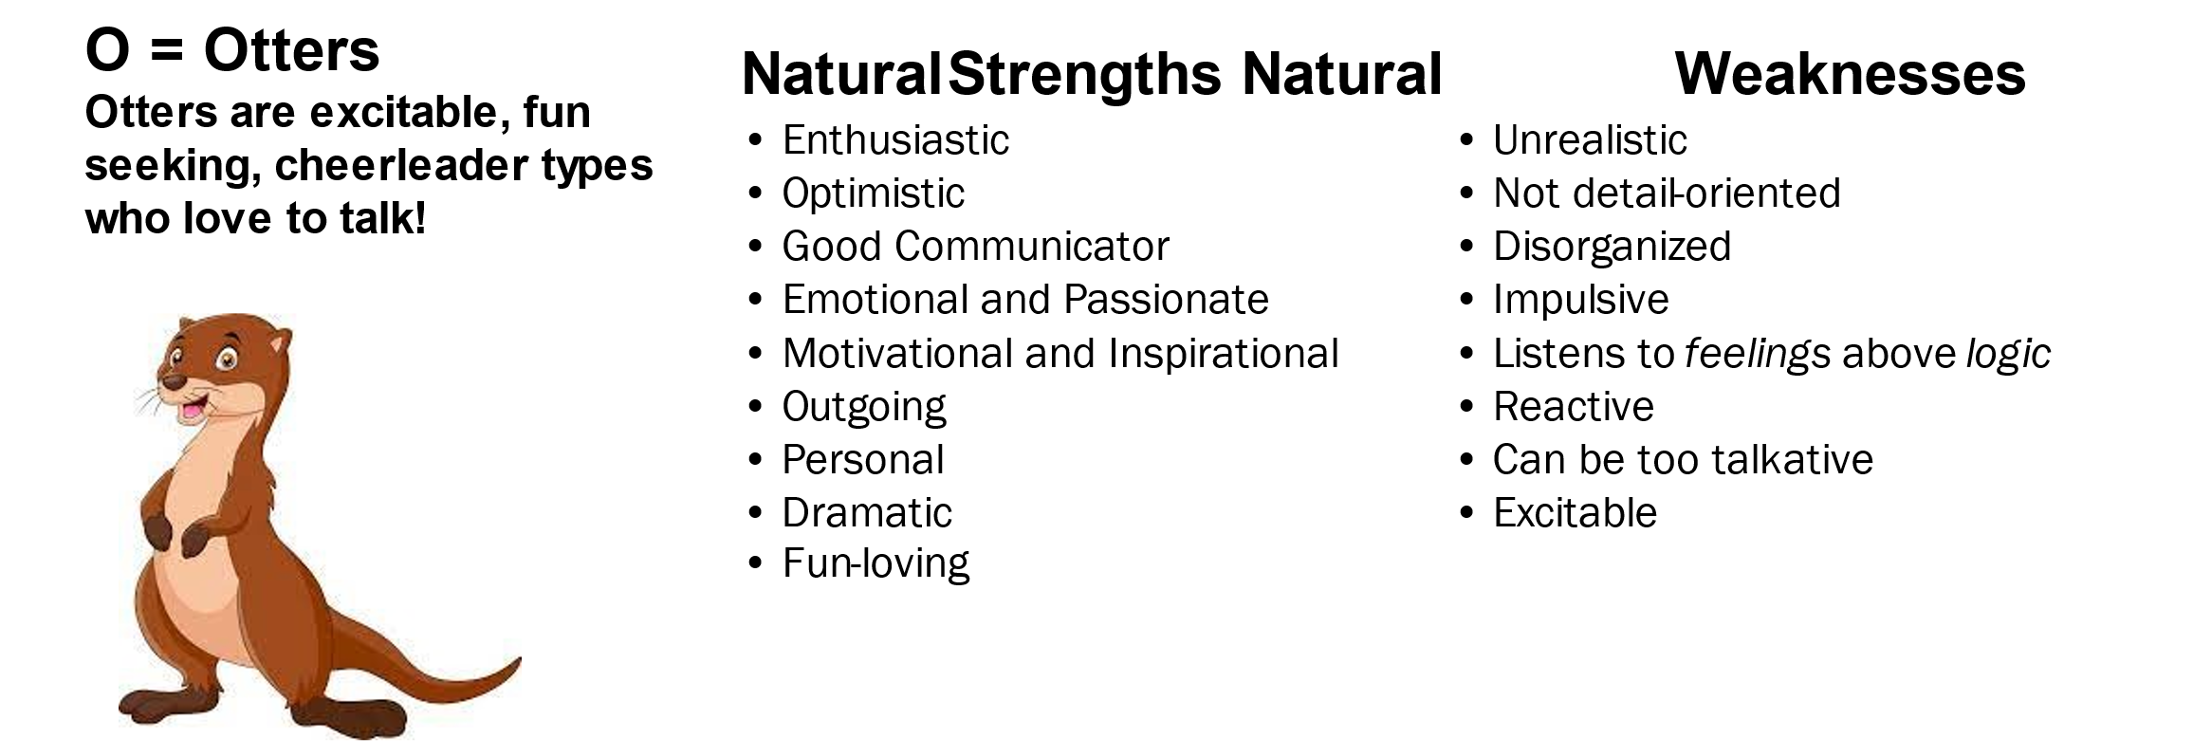
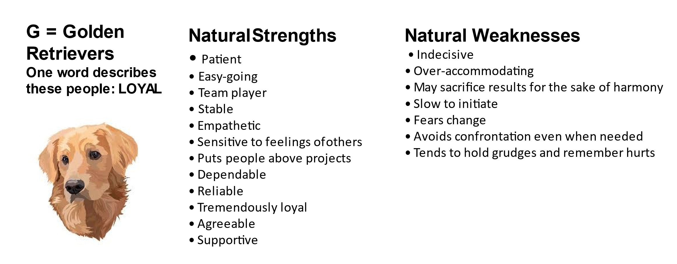
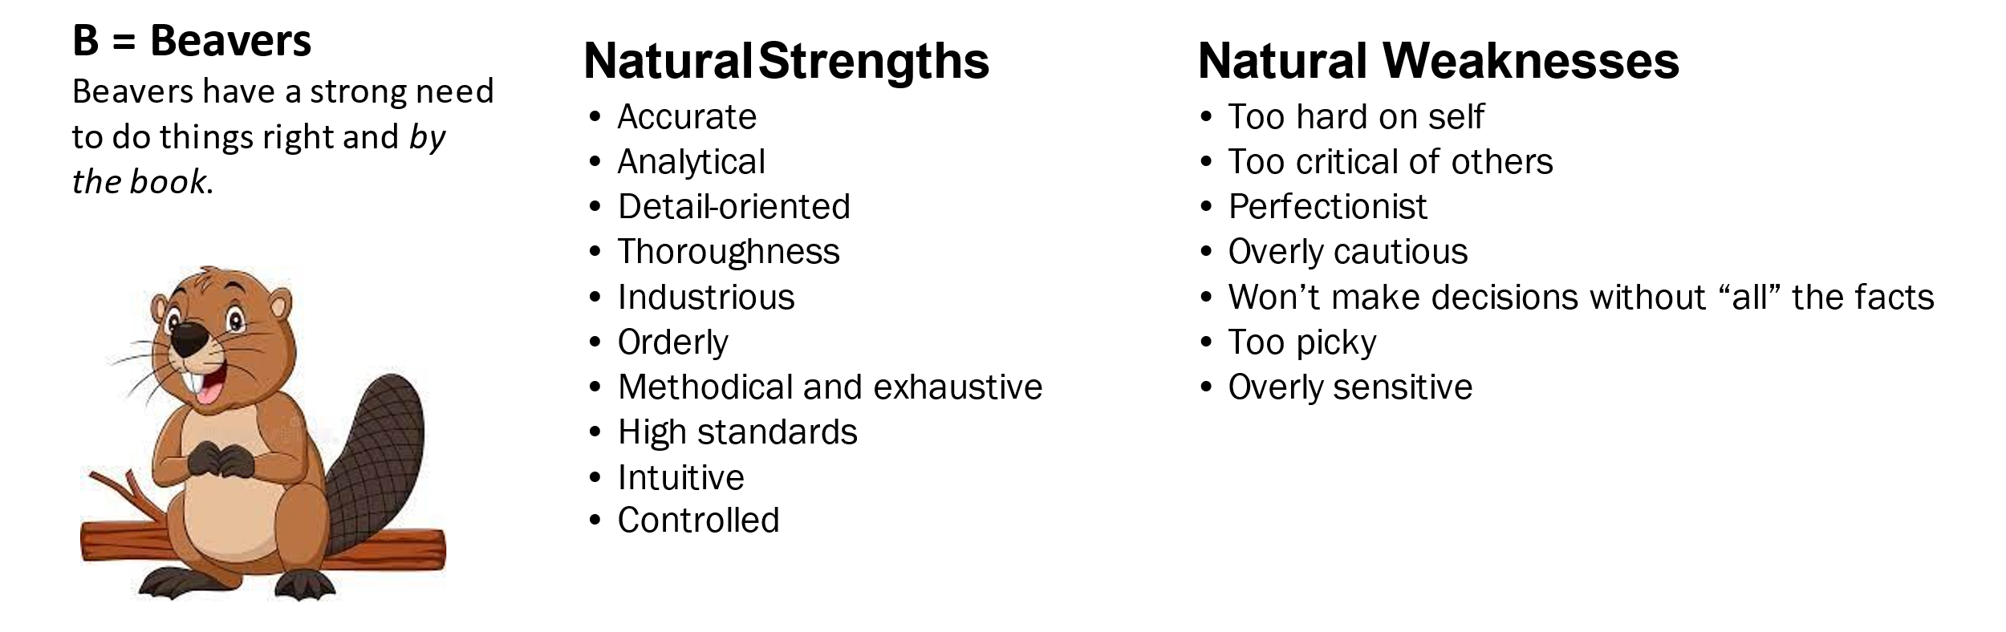
SKILLS

Look at the following “buzz words” of key skills which people often use on CV’s. Write down the key skills you have used in responsible situations such as at school, work experience, volunteering, home life or playing sport.

Problem Solving Communication Skills Organisation

Team Working Customer care Telephone skills

Caring skills Ability to learn quickly IT skills

Ability to remain calm Using on own initiative Time Management

Willing to learn/train Physically fit Handling money

Listening skills Following instructions High standard of literacy

Evidencing your Skills

It is important to be able to “prove” that you understand and
can provide examples of the skills and attributes that you claim to have.

In the table below make a list of the personal qualities and skills you possess and then
write down when you have used this skill or been that kind of person.

Skill/personal quality: | Evidence:

Be Unique
Be excited
Be positive
Be YOU!

PERSONAL STATEMENT TEMPLATE

What kind of person are you? (Tell the college how brilliant you are and why.)
………………………………………………………………………………………………………………
………………………………………………………………………………………………………………
………………………………………………………………………………………………………………
………………………………………………………………………………………………………………
………………………………………………………………………………………………………………
………………………………………………………………………………………………………………
………………………………………………………………………………………………………………
………………………………………………………………………………………………………………
………………………………………………………………………………………………………………
………………………………………………………………………………………………………………
………………………………………………………………………………………………………………
………………………………………………………………………………………………………………
………………………………………………………………………………………………………………

I really enjoy studying (favourite subjects)
………………………………………………………………………………………………………………
………………………………………………………………………………………………………………
because (reason)
………………………………………………………………………………………………………………
………………………………………………………………………………………………………………
………………………………………………………………………………………………………………

I have been told that I am very good at (skills & qualities, awards received)
………………………………………………………………………………………………………………
………………………………………………………………………………………………………………
………………………………………………………………………………………………………………

I stand out as a young person because (something you are particularly proud of as a young person)
………………………………………………………………………………………………………………
………………………………………………………………………………………………………………
………………………………………………………………………………………………………………
………………………………………………………………………………………………………………

What have you done in school? Student receptionist, Commando Joe’s, Boost sessions, Supporting Progression, Gold Standard Behaviour

Apart from my studies, in school I have taken part in
………………………………………………………………………………………………………………
………………………………………………………………………………………………………………
………………………………………………………………………………………………………………
………………………………………………………………………………………………………………
………………………………………………………………………………………………………………
………………………………………………………………………………………………………………
………………………………………………………………………………………………………………

This has helped me to develop my (skills & qualities)
………………………………………………………………………………………………………………
………………………………………………………………………………………………………………
………………………………………………………………………………………………………………

I am particularly proud of (my 100% attendance / Gold star behaviour / Sporting achievement / Duke Of Edinburgh )
………………………………………………………………………………………………………………
………………………………………………………………………………………………………………
………………………………………………………………………………………………………………
………………………………………………………………………………………………………………

What do you do outside of school? (Hobbies, interests, sports clubs, family commitments…..)

Outside of school, I take part in
………………………………………………………………………………………………………………
………………………………………………………………………………………………………………
………………………………………………………………………………………………………………
………………………………………………………………………………………………………………
………………………………………………………………………………………………………………

This has helped me to develop my (skills & qualities)
………………………………………………………………………………………………………………
………………………………………………………………………………………………………………
………………………………………………………………………………………………………………

The course I have chosen is ………………………..……………….… and has been chosen because (passion for science, interest in animals, future employment in computer science, creative flair)
………………………………………………………………………………………………………………
………………………………………………………………………………………………………………
………………………………………………………………………………………………………………
………………………………………………………………………………………………………………

I think this type of study suits me because (independent learner, practical learner, enjoy course work assessment, cope well with final year exams, would like the opportunity for work experience, etc.)
………………………………………………………………………………………………………………
………………………………………………………………………………………………………………
………………………………………………………………………………………………………………

After I leave College, I would like to study (at University or go onto Apprenticeships?)
………………………………………………………………………………………………………………
………………………………………………………………………………………………………………
………………………………………………………………………………………………………………
………………………………………………………………………………………………………………

This/these interest/s me because (reason)
………………………………………………………………………………………………………………
………………………………………………………………………………………………………………
………………………………………………………………………………………………………………
………………………………………………………………………………………………………………

In the long term I would like to go on to follow a career in (car mechanics, medicine etc.)
………………………………………………………………………………………………………………
………………………………………………………………………………………………………………
………………………………………………………………………………………………………………

Or…..I am not exactly sure which career I wish to enter but more generally I am interested in the fields of ( science based careers, computer related careers, business related careers, art and design careers, healthcare, social work careers, etc)
………………………………………………………………………………………………………………
………………………………………………………………………………………………………………
………………………………………………………………………………………………………………

Or…..I am unsure at the moment what career I would like to pursue in the future, but I am someone who wants to select courses on the basis of subjects that will motivate and interest me.

Notes
………………………………………………………………………………………………………………………………………………………………………………………………………………………………………………………………………………………………………………………………………………………………………………………………………………………………………………………………………………………………………………………………………………………………………………………………………………………………………………………………………………………………………………………………………………………………………………………………………………………………………………………………………………………………………………………………………………………………………………………………………………………………………………………………………………………………………………………………………………………………………………………………………………………………………………………………………………………………………………………………………………………………………………………………………………………………………………………………………………………………………………………………………………………………………………………………………………………………………………………………………………………………………………………………………………………………………………………………………………………………………………………………………………………………………………………………………………………………………………………………………………………………………………………………………………………………………………………………………………………………………………………………………………………………………………………………………………………………………………………………………………………………………………………………………………………………………………………………………………………………………………………………………………………………………………………………………………………………………………………………………………………………………………………………………………………………………………………………………………………………………………………………………………………………………………………………………………………………………………………………………………………………………………………………………………………………………………………………………………………………………………………………………………………………………………………………………………………………………………………………………………………………………………………………………………………………………………………………………………………………………………………………………………………………………………………………………………………………………………………………………………………………………………………………………………………………………………………………………………………………………………

